**What is BVA?**

In software testing, the ***Boundary Value Analysis (BVA)*** is a [***black box test***](http://toolsqa.com/software-testing/black-box-testing/)design technique based on test cases. This technique is applied to see if there are any [***bugs***](http://toolsqa.com/software-testing/difference-between-error-mistake-fault-bug-failure-defect/)at the boundary of the input domain. Thus, with this method, there is no need of looking for these errors at the center of this input.

BVA helps in testing the value of boundary between both valid and invalid boundary partitions. With this technique, the boundary values are tested by the creation of test cases for a particular input field.

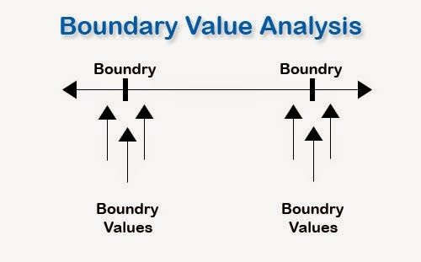

### ***An Example of Boundary Value Analysis:***

Consider the testing of a software program that takes the integers ranging between the values of -100 to +100. In such a case, three sets of the valid equivalent partitions are taken, which are – the negative range from -100 to -1, zero (0), and the positive range from 1 to 100.

Each of these ranges has the minimum and maximum boundary values. The Negative range has a lower value of -100 and the upper value of -1. The Positive range has a lower value of 1 and the upper value of 100

While testing these values, one must see that when the boundary values for each partition are selected, some of the values overlap. So, the overlapping values are bound to appear in the test conditions when these boundaries are checked.

These overlapping values must be dismissed so that the redundant test cases can be eliminated.

So, the test cases for the input box that accepts the integers between -100 and +100 through BVA are:

* Test cases with the data same as the input boundaries of input domain: -100 and +100 in our case.
* Test data having values just below the extreme edges of input domain: -101 and 99
* Test data having values just above the extreme edges of input domain: -99 and 101

This is a very basic example to understand the BVA testing technique!

With this technique, it is quite easy to test a small set of data in place of testing the whole lot of data sets. This is why, in software testing and quality management services**,**this method of testing is adopted more often.

***Evaluation of Boundary Value Analysis as a Software Testing Technique***

### Boundary Value Analysis Advantages:

* The BVA technique of testing is quite easy to use and remember because of the uniformity of identified tests and the automated nature of this technique.
* One can easily control the expenses made on the testing by controlling the number of identified test cases. This can be done with respect to the demand of the software that needs to be tested.
* BVA is the best approach in cases where the functionality of a software is based on numerous variables representing physical quantities.
* The technique is best at revealing any potential UI or user input troubles in the software.
* The procedure and guidelines are crystal clear and easy when it comes to determining the test cases through BVA.
* The test cases generated through BVA are very small.

### ***Boundary Value Analysis Disadvantages:***

* This technique sometimes fails to test all the potential input values. And so, the results are unsure.
* The dependencies with BVA are not tested between two inputs.
* This technique doesn’t fit well when it comes to Boolean Variables.
* It only works well with independent variables that depict quantity.